TRAINING OF TRAINERS ON ESTABLISHING KITCHEN GARDENS IN RURAMBO VILLAGE – NGORORERO DISTRICT

- Introduction
The HortInvest in collaboration with the Landscape Restoration projects organized a two-day (6-7th Oct 2020) training of trainers, ToT on establishing kitchen gardens in 11 villages of four districts where both projects are operating.

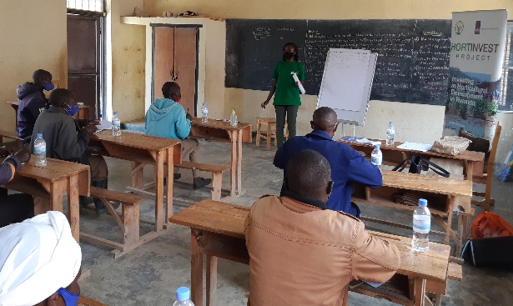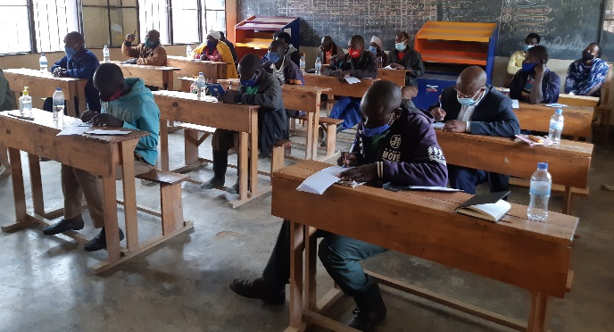
Picture 1: Anathalie speaking to participants of the ToT in Rurambo village
The HortInvest is a 4-year project funded by the Embassy of the Kingdom of the Netherlands (EKN) in Rwanda; and, operates in six districts of Karongi, Rutsiro, Rubavu, Nyabihu, Ngororero and Muhanga, promoting vegetable and fruits production for local and regional markets; improving food and nutrition security; enhancing vegetables and fruits exports to international high markets; and, emphasizing on an enabling environment for the horticulture development. Likewise, the Landscape restoration is an EKN funded project that operates in the four districts of Ngororero, Rubavu, Nyabihu and Rutsiro. It safeguards the catchment of the Sebeya river.
To promote integration of resources for a bigger impact, both projects agreed to collaborate in improving food and nutrition security in 11 villages of their common districts. Not only the collaboration brings in synergy but also promotes household nutrition, encourages districts adoption, enhances the know-how through skills transfer, and collaboration between two EKN funded projects for a bigger impact.
In this training, kitchen gardens were highlighted as affordable ways to produce and consume vegetables and fruits. In addition, community members were provided with vegetables seeds. This report highlights how a training of trainers on establishing kitchen gardens was conducted in Rurambo village of Muhanda sector in Ngororero district and subsequent plans for scaling-up the training.

- Proceeding of the Training
Fifteen participants (2 female) consisted of the village leader, 9 Isibo leaders, 4 community health workers, and a one farmer promotor. In addition, the cell socio-economical development officer, SEDO, two sector representatives namely the health and sanitation and land and forests officers participated in the training.
The training used a participatory approach and consisted of both practical and theoretical part on the construction of kitchen gardens, how to grow vegetables and fruits, the importance of consuming vegetables and fruits; and, organic fertilizer production.
Two types of kitchen gardens namely the double dug bed and kitchen garden in terraces were highlighted and trainers provided enough information on kitchen garden construction. Regarding the double dug bed kitchen garden, participants were requested to pay an attention on the height of the bed and the organic materials they put since this enhances enough space for growth (in case of tubers), and both technics allow an optimum water leak-out for a proper aeration of the soil. Likewise, the audience was reminded that this holds for kitchen gardens in terraces. In addition, for kitchen gardens in terraces, trainers emphasized on the role of mixing structural materials with soil and mature manure to supply enough microorganisms and adequate conditions for vegetable growth.
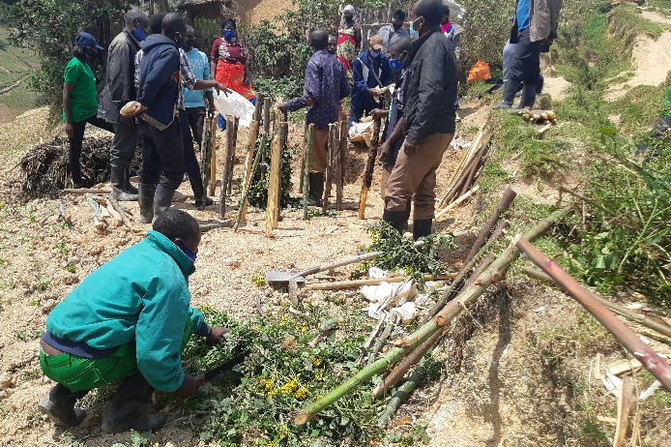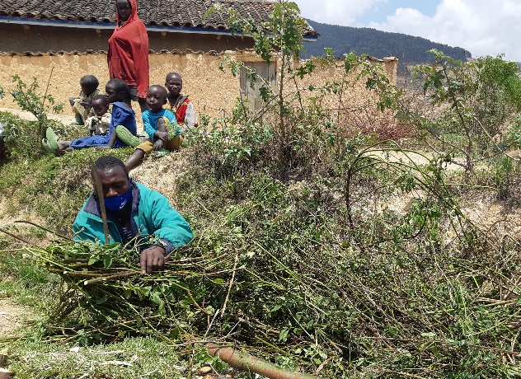
Picture 2: A participant chopping plants (left) and small trees (right) for structural improvement of the soil
The second day was allocated to practical training. All participants, cell and sector representatives gathered to one household to construct a kitchen garden in terraces. The beneficiary is Nzamwitakuze Claudine, a 29-year-old mother of 5 children (3 female) belonging in category 3 of Ubudehe. Two of her children are severely malnourished (in red) and this and her poverty were the reason of the selection. Claudine provided land and manure for kitchen garden construction and was part of the trainees. All participants were shown how a kitchen garden is constructed step by step in a participative way.
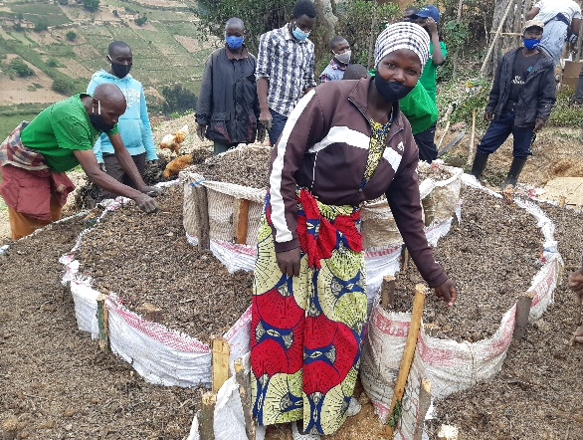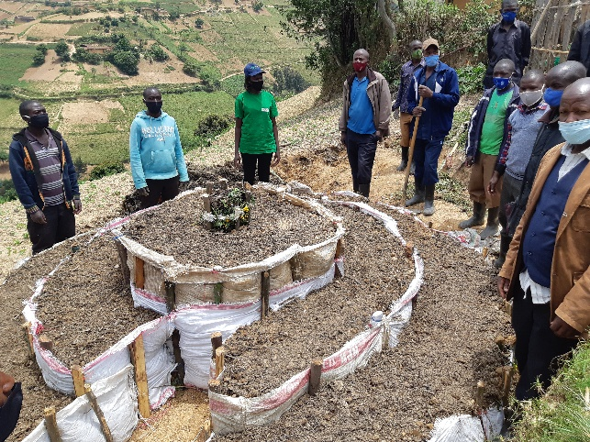
Figure 3: Claudine, the owner (left) and participants of the ToT of the newly built kitchen garden
After the construction, four types of vegetables (beetroots, carrots, spinach, suiss chard and Amaranthus) were planted respecting inter-distance crops (to minimize nutrients competition and to promote easy maintenance) in the newly constructed kitchen gardens. The owner was requested to cover it to protect the seeds against both heavy rain and sun. In addition, she was reminded to water the kitchen garden on days without rain. All participants were provided with seeds of the above-mentioned vegetables and were taught on how to make a proper transplanting. Only carrots will not need transplanting.
- Way forward
Participants of the ToT were tasked to scale-up the training to fellow households in the village. Considering the size of the village (182 households and 9 Amasibo in total), a plan was made for the whole village. All leaders of Amasibo (present both days of the training) will have 1) scaled-up the training and get all their households having at least one of both types of kitchen gardens and 2) provided seeds to fellow households by the end of this month of October 2020. By 15th November 2020, projects staff will have made a follow up field visits to identify and address key challenges.
The training was officially closed by the health and sanitation officer at Muhanda sector, thanking SNV for supporting the sector on kitchen gardens establishment in Rurambo village. She appreciated the high men engagement in the training and requested to be reflected in vegetable consumption at household level. Furthermore, she pledged to urge fellow local leaders on following up the establishment of kitchen gardens in Rurambo village to improve household’s nutrition status. Furthermore, she promised the sector will scale-up the training in other villages of the sector using the trained leaders from Rurambo village.

