The coronavirus outbreak disrupted economic activities in the world affecting financial conditions of many habitants. In Rwanda, the government opted for a total lockdown which started end March till end June. During that time, farmers have been affected in so many ways: they incurred losses as many of them could not supply the production to the markets due to the travel bans. Many of the farmers who were planning to grow vegetables in season C, could not easily access the inputs since the price was huge compared to the situation before and sometimes, input shops were out of stock. HortInvest project is working tirelessly alongside its beneficiaries around Rwanda North-West region to surmount the challenges presented by the COVID-19 pandemic. In this light, the project found it important to support the cooperatives with financial hardship due to the pandemic so that the vegetable supply chain would not be disrupted.
The support was given to 14 most vulnerable cooperatives to help them cope with the pandemic and prepare for 20/21 season A.
The project has assessed the situation from the vulnerable cooperatives and opts on the inputs (vegetable seeds, fertilizers and pesticides) support. The vegetable inputs support reaches 14 cooperatives with 379 members and are estimated to cover 62.5 Ha.
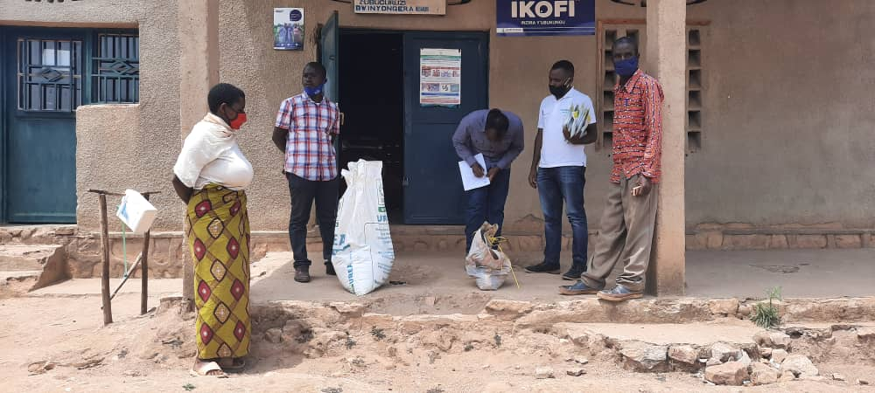  Figure 1 Inganzo Cyeza receiving inputs/ Muhanga | 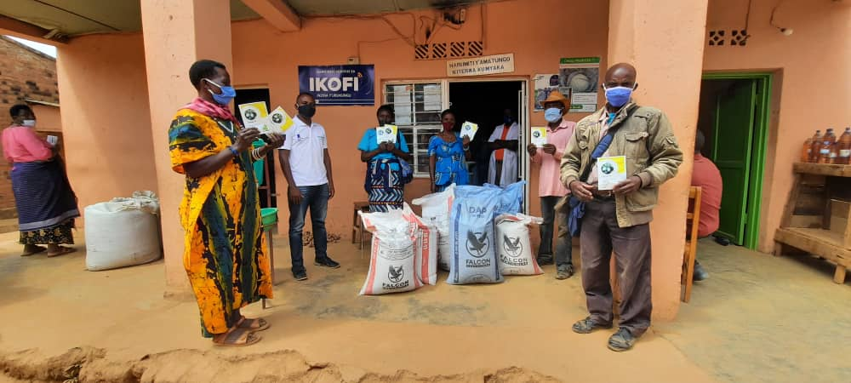  Figure 2Abishyize hamwe Kiyumba receiving inputs/ Muhanga
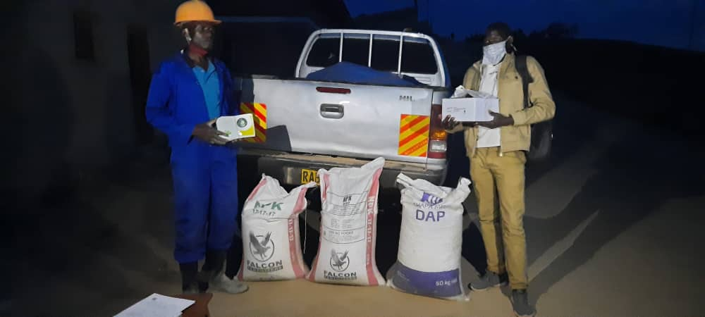  Figure 3 KOABU-Kageyo receiving inputs/ Ngororero | 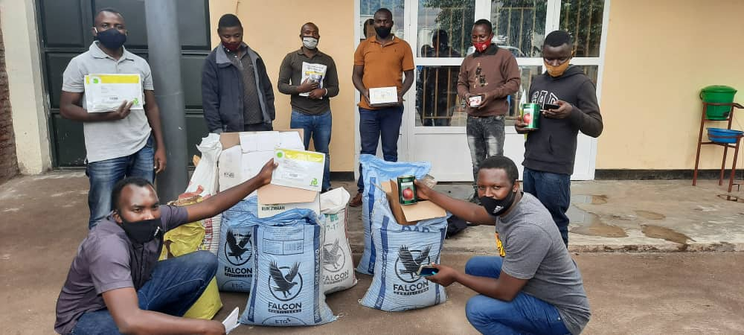  Figure 4 KOTURU receiving inputs/ Rubavu
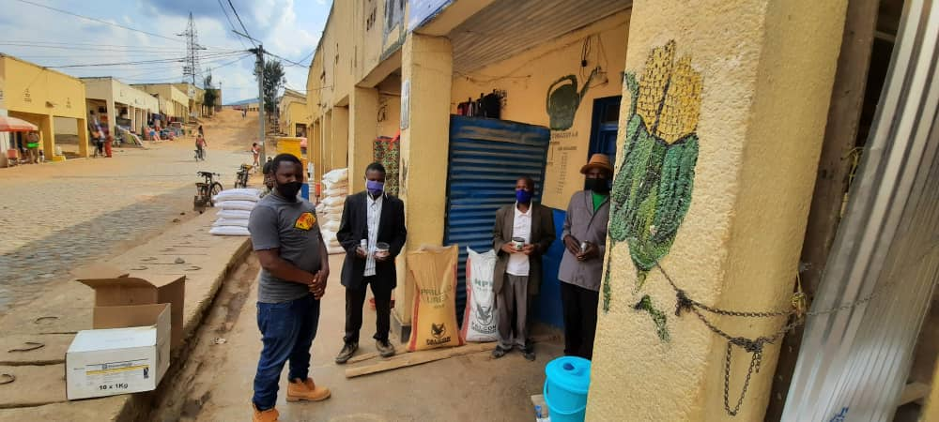  Figure 5 Ndamirabana receiving inputs/ Ngororero | 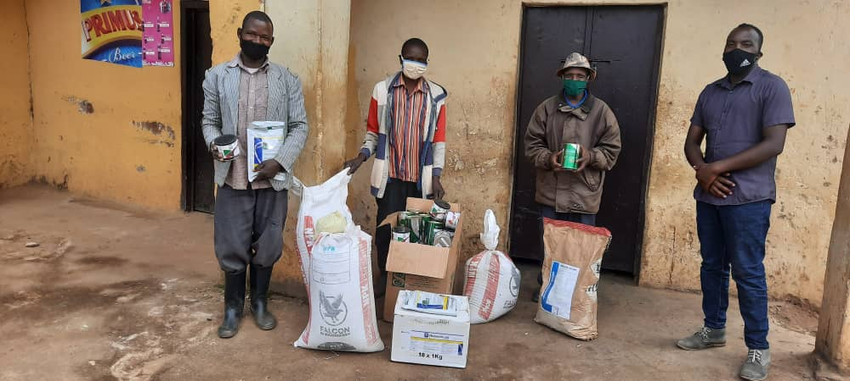  Figure 6 KOVURU receiving inputs/ Ngororero
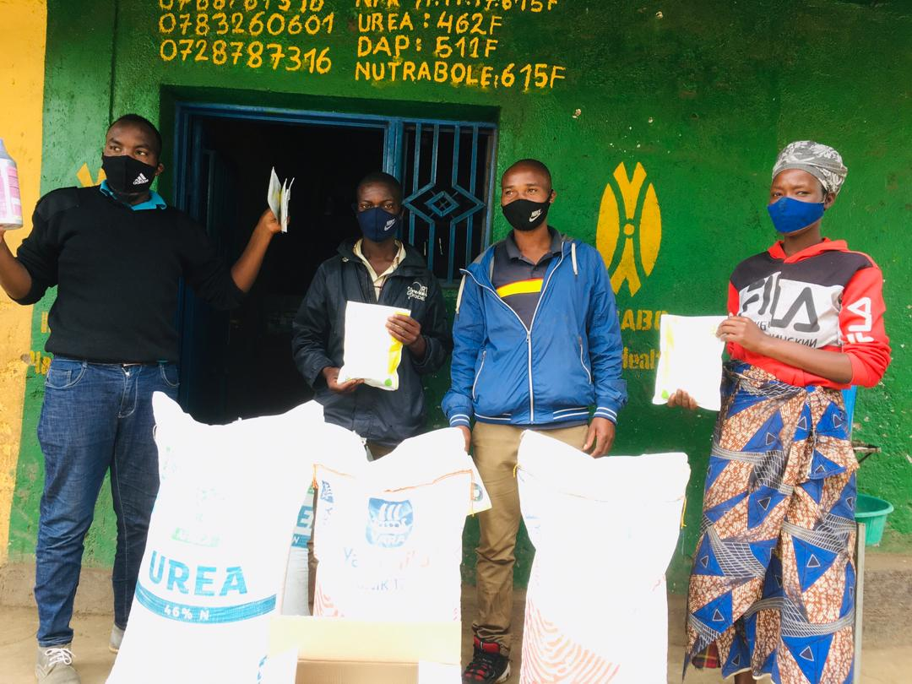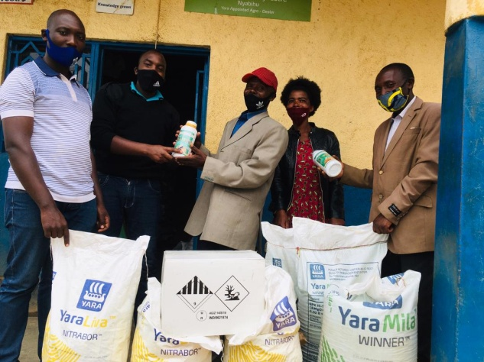  Figure 7 KOATUMU& KIZ's receiving inputs/ Nyabihu | 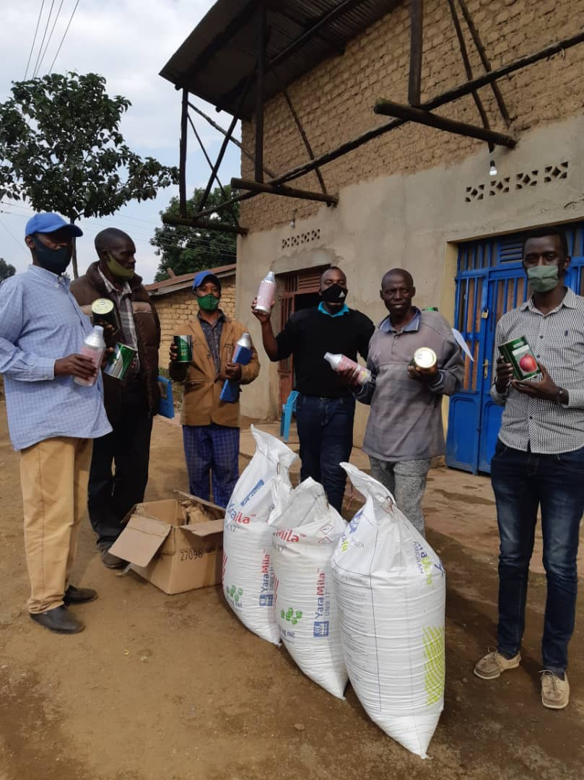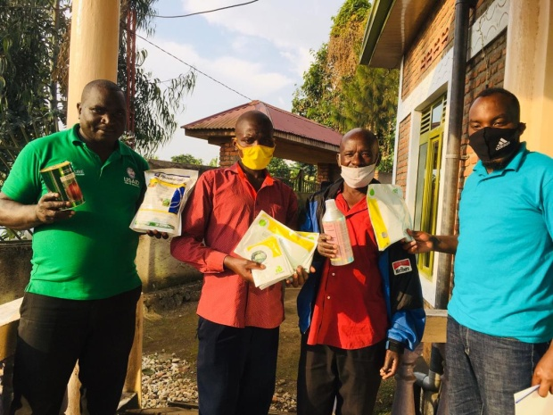  Figure 8 KOTUIBU& COAIRU's receiving inputs/ Rubavu
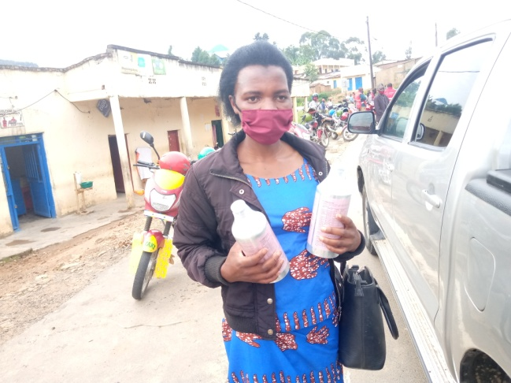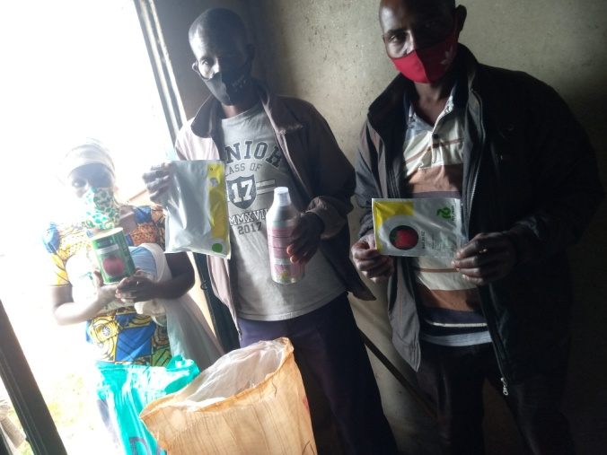  Figure 9 KOOPTNYA& KORANUMWETE receiving inputs/ Rutsiro | 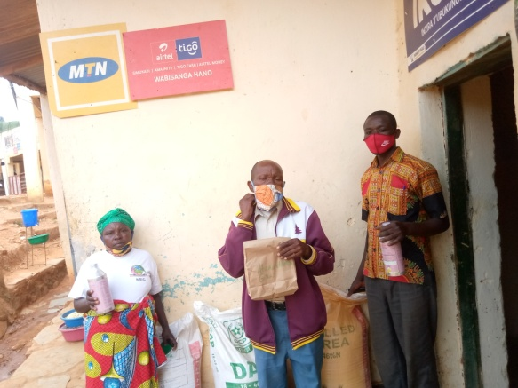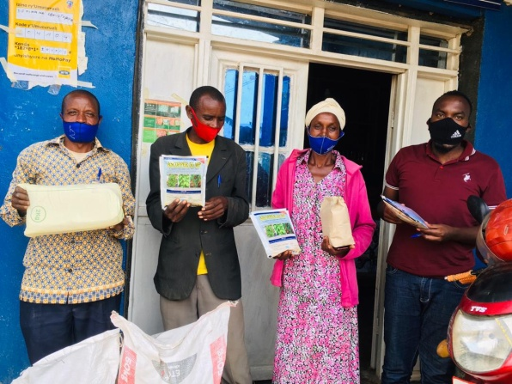  Figure 10 Abakundamurimo& COPMARU receiving inputs/ Karongi

The cooperatives appreciated the support and are thankful to HortInvest for helping them cope with the effects of the pandemic. They committed to use properly those inputs and produce quality and quantity production. The project staff will support the cooperatives on the inputs use and follow up to make the inclusive approach real.

