To respond to food and nutrition security, HortInvest project enhanced activities such as community cooking demonstration sessions, establishment of kitchen gardens including promotion of fruit trees, , and community mobilization in six Districts of the North West part of Rwanda.
Since September 2019, community cooking demonstration sessions have been followed up and assisted directly or indirectly by the HortInvest project Nutrition District Coordinators in 6 Districts of the project area of implementation. Nutrition District Coordinators facilitated in assessing community kitchens challenges and identified lack of sufficient cooking demonstration materials such as saucepans, mats, buckets, basins, jericans and other materials like spoons, cups, plates to be used during events that HortInvest project is committed to support with community kitchens in all the 40 villages of HortInvest nutrition component area of focus.
In this October, 2020 the villages were supported with community cooking demonstration materials namely saucepans, cooking spoons, mats, buckets, basins, jericans and others like jugs, spoons, cups, plates to be used during children feeding practices. The materials were handed to community health workers in each village (BINOME/ASM) and village leader who will be responsible for these materials under supervision of Nutrition District Coordinator and local leaders. At the end of the project, the materials supervision will be handed to cell leadership as an exit and sustainability strategy. At delivery place there were different invitees namely District staff, Sector staff and other local leaders from cell level.

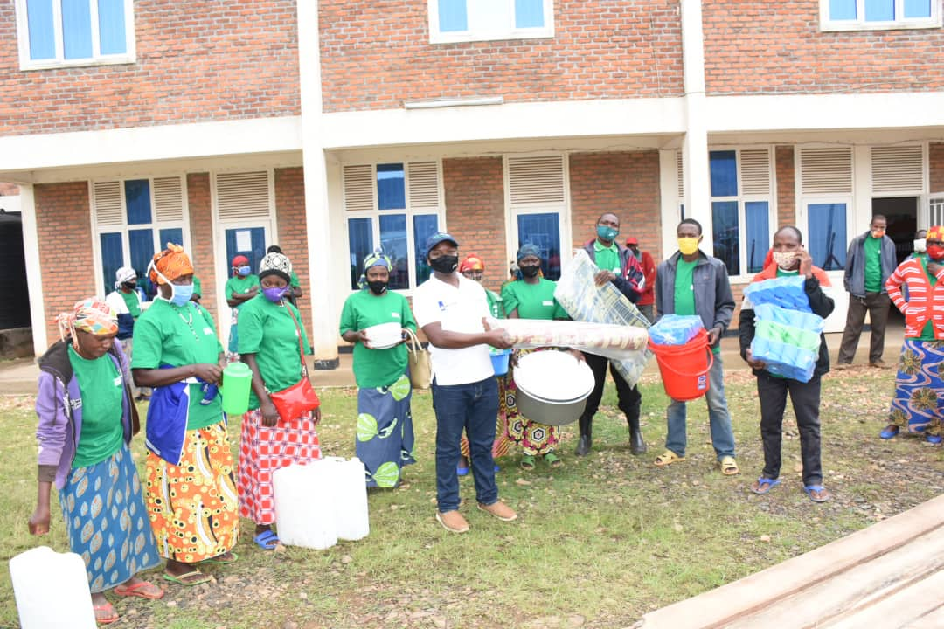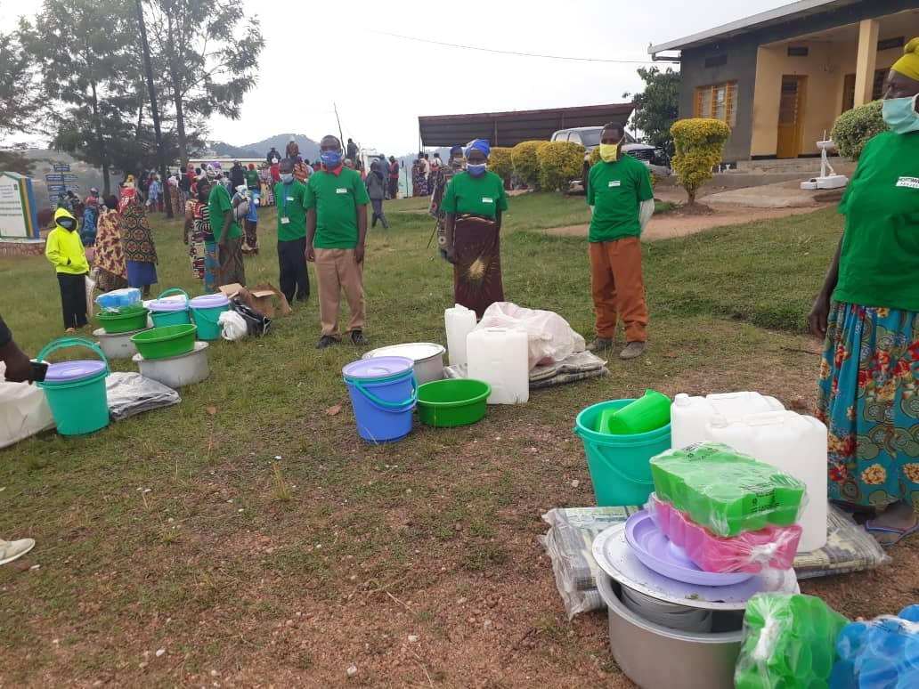
Figure 1: NAG in Karongi receiving cooking demonstration materials. Figure 2: NAG in Ngororero receiving cooking demonstration materials.
The community appreciated very much the project tremendous support in addressing malnutrition as well as improving community nutrition especially for the kitchen materials received. Cooking demonstration materials distribution will uptake of how to how improving nutritional status of women of reproductive age (WRA) and children under five years of age though the preparation of hygienic diets. These materials will help to improve hygiene and sanitation during cooking demonstration session.
The HortInvest Nutrition District Coordinators will continuously support the community with nutrition technical support and follow up to improve hygiene and sanitation during cooking demonstration sessions.

