Fruit Logistica
Berlin, Germany
05th – 07th February, 2020

On February 4th 2020, HortInvest organized a trip to Fruit Logistica in Berlin for a group of seven exporters, beneficiaries and potential beneficiaries of IIF. Fruit Logistica is the biggest fruit and vegetables exhibition in Europe and the objective of attending it was to help exporters understand better the international fruit and vegetable business and connect with a wide variety of value chain actors, and get exposure on how business is done around the world.
In addition to 7 exporters supported by HortInvest, they was another group of eight exporters supported by NAEB. The whole group was supported by HortInvest in shipping their sample produce that were exhibited in Rwanda Fresh Booth.
The Rwanda Fresh booth received many visitors throughout the three days of exhibition and exhibitors got different contacts with potential buyers; they also received visits from their current buyers who got a chance to give them feedback on their ongoing businesses. The group was very much motivated by the participation of the Rwandan Embassy in Germany throughout the three days and by the Ambassador himself.
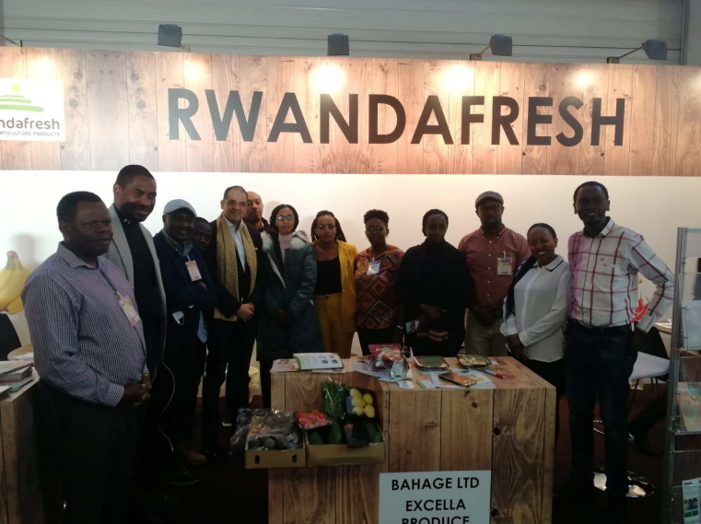
Exporters’ workshop to the Netherlands
Utrecht, Netherlands,
10th – 12th February, 2020

From Fruit Logistica. The seven exporters traveled to the Netherlands for a series of workshops and visits to different companies and potential buyers. Trainings that were given covered marketing, cost-price calculation and contract management, customer relations and loyalty, export procedure; quality control and requirements and overview of EU market and specialism. They also visited supermarkets, input suppliers and other value chain actors.

Companies visited are: HSI (input supplier), Morgan Cargo for cargo handling, EOSTA – distributor of organic fresh fruits and vegetables; supermarkets to see prices and product quality when on the product is on the shelves; and Van Oers United – a distributor and grower of fresh fruits and vegetables.

At the end of the workshops, exporters got a chance to evaluate themselves on how far they have gone taking into consideration the targets they had set during the workshops of November 2018 and to set new targets for the coming year when they are back to Rwanda, and taking into consideration what they have learnt and saw as international marker requirements.

