  - HortInvest Gender and Youth workshop
  - Onomo Hotel, Kigali
  - 28-29 January 2020

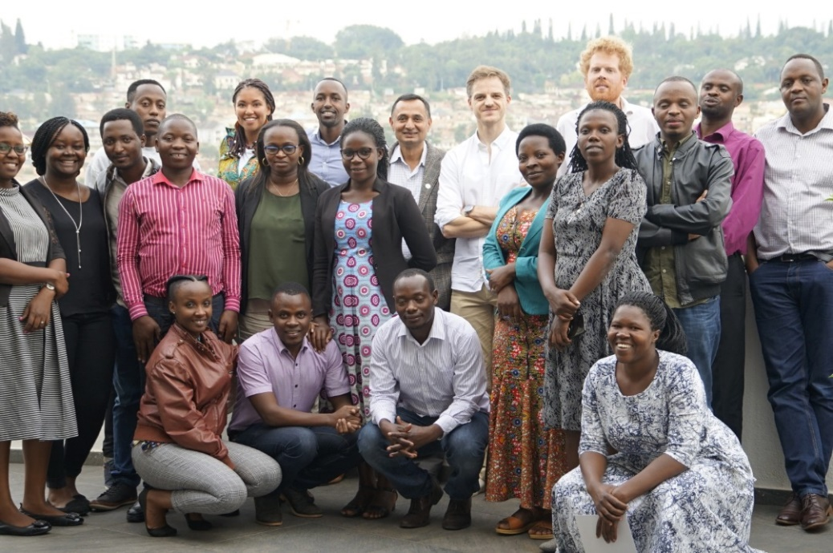
HortInvest had 2 days works on gender and youth at Onomo Hotel Kigali. The workshop had an objective of building the capacity of HortInvest project national staff on youth and gender issues, to develop a more collective understanding of the types and scale of interventions made by the project so far, to discuss these and propose any potential new interventions. This workshop was followed by a half-day meeting with the HortInvest youth & gender focal group to discuss how to monitor these activities, capture and share lessons learned, for the remainder of the project. The workshop was facilitated by Thomas Tichař, a Youth & Gender Advisor in Food Systems at Wageningen University and Research and was attended by 22 HortInvest staff (picture 1).
Picture 1: HortInvest National staff who attended the gender and youth workshop
The workshop loosely followed a 4-stage process as follows:
- From individual to common vision. Collecting impressions and ideas from participants on their experience of how the project so far has/has not benefited youth and women. Using this to understand how much overlap or difference there is of this across the project.
- From common vision to benchmarking. Using this loose overview to develop a 4-step benchmarking process of ‘attract, reach, benefit, empower’ to agree on a HortInvest-specific means of understanding scale of outcome/impact so far.
- From benchmarking to next steps. Agreeing on results that everyone collectively, and by partnership, wants to achieve in the remainder of the project. This should be realistic given the time and budget available.
- Actioning and M&E of next steps. With the gender and youth focal group, reflect on workshop process/progress (highlights, main insights), agree on agenda for remaining period and how to action and monitor the remaining objectives, results and activities.
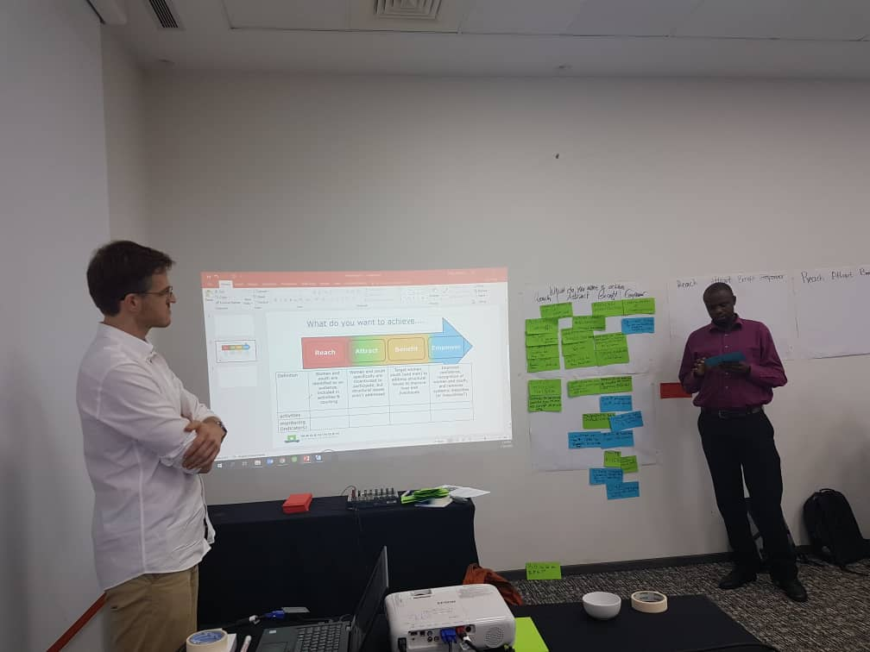
Using the said methodology, the HortInvest team identified ongoing activities that they categorized under each 4 steps of targeting women and youth: Attract, Reach, Benefit, Empower. Following this, the team also brainstormed activities targeting women and youth that could be improved or new activities that are a follow up of already existing activities. The scale of ambition (e.g. benefit) for the proposed activities indicates that the team is looking to address more structural issues in the remaining two years of the project (picture 2).
Picture 2: a staff categorizing current (green) and proposed (blue) activities targeting women and youth in HortInvest

In addition to this, external speakers representing youth and women entrepreneurs in horticulture sector were invited to present and reflect on issues women and youth face in the horticulture sector, and existing opportunities that the HortInvest can build on.
After the workshop, the gender and youth focal group used the information gathered by all the staff and planned for next steps. The focal group developed a Gender and Youth Guidance document which will serve as a guidance within the project. It is intended as reference for the focal group to manage their activities, outputs and to be able to communicate this to others in the HortInvest project. It is a living document and should be updated as needed.

