Felicien SEBAHIRE : A FULFILLED FARMING DREAM AT GITWA CELL IN KARONGI DISTRICT
SEBAHIRE Felicien is a 50 years old farmer who lives with his wife and children in Gitwa cell, Rubengera sector, Karongi district in Western province. Before HortInvest project, he used to grow maize, beans, cassava, sweet potatoes and banana using traditional methods on less than 1 Hectare of land, to feed his family. He pointed out that during his life, he has never cultivated any fruits and vegetables although he used to try to grow passion fruits on 0.05 hectare and he failed because of poor crop management skills.
Improved livelihood
SEBAHIRE was excited to meet HortInvest project staff in 2018. “Through the local government officials, we were sensitized to be part of the new horticulture project in our district and different farmers in our community joined.” Sebahire pointed out that through trainings on horticulture value chain, Farmer Field Days, Business to Business events and through practices and experience on the demonstration site, he has gained enough knowledge and skills to start his own farming business. ‘’I am really thankful to HortInvest project for providing me with a knowledge package including selection of good quality and improved seeds/seedlings and integrated pest management (IPM). This enabled me to harvest much more produce of good quality and in return reduced the production cost”, he added.
Sebahire is now growing cucumbers on 0.13 hectare, tomatoes on 0.4 hectare, yellow and red sweet peppers on 0.1 hectare, onions on 0.8 hectare, carrots on 0.3 hectare, beetroots on 0.1 hectare, broccoli on 0.2 hectare and passion fruits on 0.17 hectare. SEBAHIRE’s family livelihood has changed for better after being engaged in growing horticultural crops. Last season he harvested 16,250 kg of cucumbers; 3,174 kg of passion fruits, 24,000 kg of onions; 220 kg of beetroots, 900 kg of carrots, which earned him around 6 million Rwandan Francs at the end of the season.
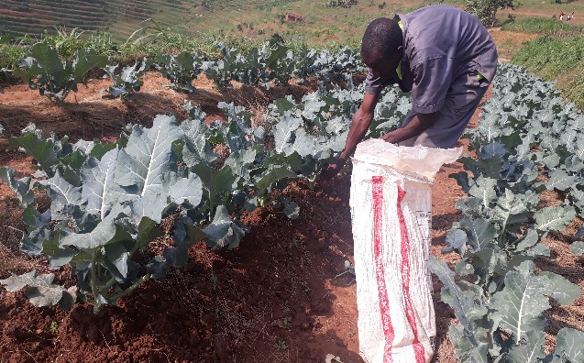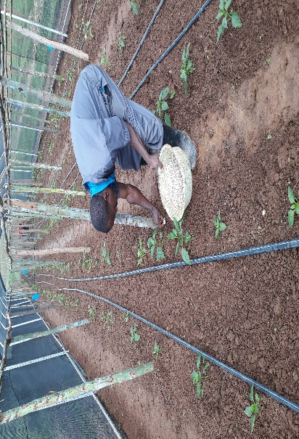
SEBAHIRE adding fertilizer to his broccoli SEBAHIRE was learned GAP at the HortInvest demo site
SEBAHIRE is now motivated to invest in horticulture. To extend his farming business, he has rented a plot of 3 hectares for 2 years for 1 million Rwandan Francs and has started to use improved seeds. “I only use improved seeds, I have invested 404,400 Rwandan Francs to buy 52 packages of cucumber seeds, 0.5 kg of carrots, 10 packages of sweet peppers and beetroots seeds from Holland Greentech”. Apart from this investment, he is committed to use the right amount of organic and chemical fertilizers for the success of his business next season. “I have also bought a solar panel of 1,200,000 Rwandan Francs to electrify my house and this electricity helps my neighbors to charge their phones at free of charge. Furthermore, I have supported the district office by giving 1,743 kg of cucumber to support vulnerable and needy families during the COVID-19 pandemic period”
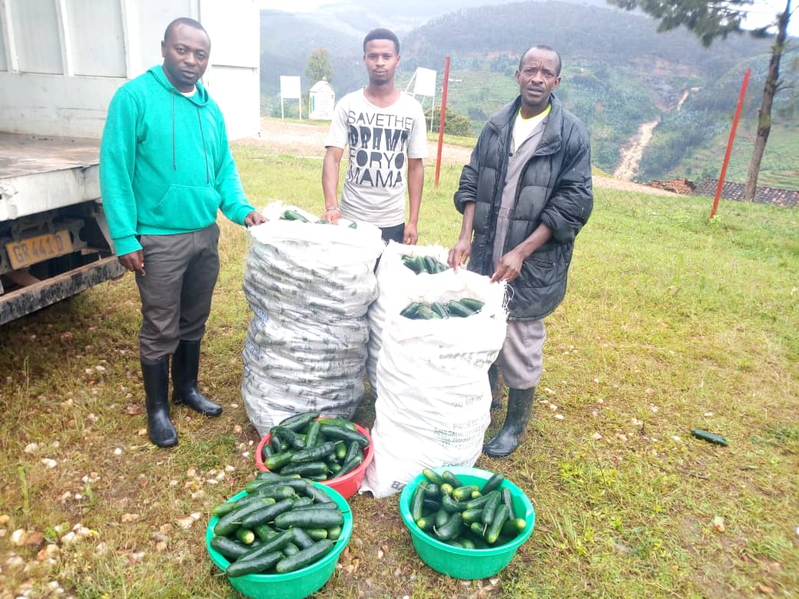 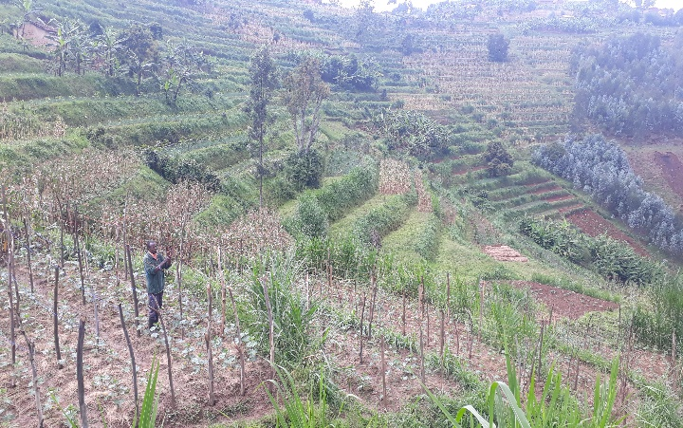Cucumber given by SEBAHIRE were ready to be packed in truck SEBAHIRE was trellising his cucumbers
In the community SEBAHIRE became a role model and he currently leads a group of 34 farmers, by advising them on their daily farming activities in growing horticulture crops. Through the network he developed during business-to-business meetings, Sebahire linked farmers in this group to different hotels in Karongi and Muhanga to which they are selling their aggregated produce.

