Dutch strawberry varieties in Rwanda

In February 2020, HortInvest partnered with FlevoBerry, a strawberry breeding company to introduce two Dutch strawberry varieties in Rwanda. The idea came after a GAP mission done in 2019 by a strawberry expert from FlevoBerry, who proposed to trial Dutch varieties in Rwanda since the variety which was grown is unknown. 5000 plantlets were distributed to two cooperatives (KOABUNYA in Rutsiro District and CODFM in Muhanga District).

CODFM is a women-led cooperative with 30 members which started its activities in 2008. The collective farming is done on 3ha located in Miguramo marshland/ Muhanga. It was included in HortInvest portfolio in 2019. Before joining HortInvest, it produced 240kg of strawberry weekly on 3ha and sold to Urwibutso Entreprise-Muhanga branch. In the trajectory, it received different trainings which targeted to increase the farmers ‘capacity and sense of business. Among the trainings include training on good agricultural practices, workshop on soil fertility, etc. With the application of the knowledge from the trainings, the production started to increase and reached 500kg per week. In 2020, a trial field of 500m² to test two Dutch varieties (Bravura and Furore) was established. The cooperative was supported by a Dutch expert to establish the field and gave fertilization schedule guide them till the harvesting time. The strawberries were growing well until April when the marshland was flooded, and the rain wiped away almost all the crops in the marshland. Fortunately, the cooperative was able to rescue the trial field and it is harvesting 20kg/week on 500m². Those two varieties are bigger and sweeter compared to the traditional variety they used to grow. However, farmers prefer Bravura over Furore since the former is way bigger than the latter.

Since the harvest of those two varieties, the cooperative received more demand from supermarkets, hotels, bakeries, and individuals. The cooperative is selling 1 kilogram at 2000 FRW and all the production is taken.

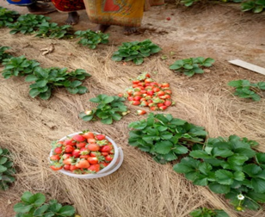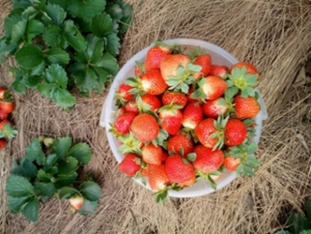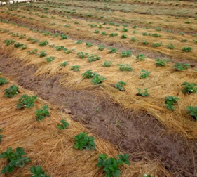
Figure 1: Trial field at CODFM

KOABUNYA cooperative is another cooperative engaged in strawberry production. It is located in Nyabirasi sector, Rutsiro district. It was established in 2014 and has currently 449 members and 1,261 potential future members. Apart from strawberry, the cooperative is also engaged in the production of maize, beans, and vegetables. The individual members own 490 ha and the cooperative owns 3ha where it does collective farming.
KOABUNYA joined HI project in June 2019, and since then the cooperative started collective farming and selling of strawberry production. Before the HI project, the cooperative only provided information on two buyers who dealt with members individually. The cooperative was not able to track all the production sold by its members. It only estimated 500kg/week. Its collaboration with HortInvest resulted in a potential market where KOABUNYA was linked to COOPEDUSH (a cooperative also working with HortInvest based in Karongi) to supply 200 kg/ week, which are subject to increase as the cooperative keeps on engaging more farmers to join the strawberry production. KOABUNYA also established a trial field for Bravura and Furore on 600m² where it currently harvests on average 25kg/ week. KOABUNYA is now collectively selling the production to different buyers in Kigali at 1500 Frw/kg.

In its cooperative development component, HortInvest will continue to support those two cooperatives to increase the area under strawberry production and build farmers’ capacity in good agricultural production and business. The project is supporting KOABUNYA to get irrigation materials and proper harvesting equipment which will reduce post-harvest losses.

