TUBUSEZERERE COOPERATIVE SUCCESS STORY:
MOVING FROM SBUSISTENCE TO SEMI-COMMERCIAL FARMING FOR VEGETABLE PRODUCTION
TUBUSEZERERE is partially a horticulture cooperative established in 2010 by a group of mainly women from Shyogwe and Nyamabuye sector in Muhanga district. The production area of this cooperative is 1 hectare, where vegetables are produced. The value of one cooperative share is now at 50,000 Rwf, while they started at a value of 5,000 Rwf per member.
The journey of cooperative members from 2010 to May, 2020
Murekatete, the president of the cooperative, explains the origin of the cooperative. “For TUBUSEZERERE, agriculture had always been a subsistence farming and we never imagined that we could shift from subsistence to commercial farming. We started in 2010 as a farmer group of 20 members working together in our neighbouring farms of 400 are. In 2012 we became a registered cooperative at the Rwanda Cooperative Agency (RCA) and the number of members increased from 20 to 50 and land size increased from 0.40 hectare to 1 hectare. We practiced subsistence farming, planting all kinds of crops on our land: Carrots, cabbages, Irish potatoes and maize. Yields were always low due to a lack of improved varieties and a lack of knowledge on good agriculture practices,” Murekatete continues to explain that there often wasn’t enough food to feed the families in between harvesting seasons.” Actually, we were not getting enough yield due to above mentioned reasons and in addition to that, the market was not available to us and once we got it the prices were low because of the low quality of our produces.” HortInvest started working with TUBUSEZERERE in 2019 and has established demonstration plots where hybrids seeds of different vegetables have been introduced to the cooperative. “We started to use the new seeds on our farms where we used to grow local varieties before and in addition to that HortInvest trained cooperative members on good agriculture practices and marketing strategies for horticulture produces”, says Murekatete.
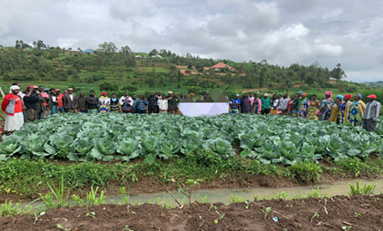
Figure 1: Training TUBUSEZERERE Cooperative members on GAP

The cooperative president revealed that with support from HortInvest, TUBUSEZERERE managed to move from subsistence farming to commercial farming. The yields have increased significantly and the quality of our produce improved as well. “While we used to harvest only 40 heads of cabbages per are, we started getting 500 heads of good quality cabbages. Before this crisis of COVID-19, we were selling cabbages, carrots, cucumbers and cauliflowers collectively as cooperative at secondary schools and Splendid Hotel all located in Muhanga District. The improved access to market was facilitated by HortInvest after an event known as business to business meeting. During this meeting we met with different actors in the value chain to initiate business relationships with them. We no longer have a challenge of access to markets because we have been linked to new buyers.”
After TUBUSEZERERE became a market oriented cooperative due to HortInvest support, the increased incomes made it possible to expand the area of production for vegetables. As mentioned above, from July 2020, 1 hectare will be used to produce different vegetables because most of the customers are schools which will reopen in September 2020. In addition to that the members of cooperative have adopted the new horticulture production technologies promoted by HortInvest on their own farms and the cooperative is helping them to get a market.
TUBUSEZERERE Cooperative is now producing cabbages, carrots and Irish potatoes that will help the cooperative to keep generating incomes during this pandemic crisis of COVID-19. “We are food secure and financially stable,” Murekatete said. “Thanks to the trainings we received, and the practical experience we gained, we can comfortably say we have acquired lifelong skills and confidence.”
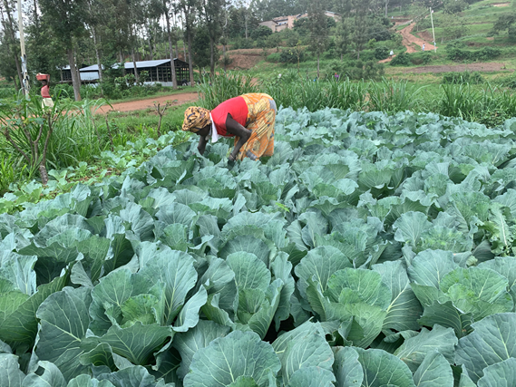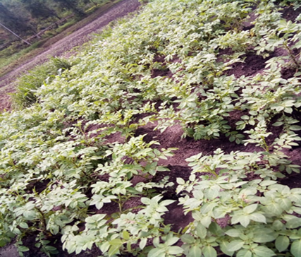
Figure 2: Production of Cabbages and Irish Potatoes at TUBUSEZERERE Cooperative/Shyogwe-Muhanga District

